# NITTE MEENAKSHI INSTITUTE OF TECHNOLOGY

(AN AUTONOMOUS INSTITUTION, AFFILIATED TO VISVESVARAYA TECHNUNIVERSITY,BELGAUM, APPROVED BY AICTE & GOVT.OF KARNATAKA



## OBJECT ORIENTED PROGRAMMING WITH C++

***COURSE PROJECT REPORT***

on

# GUI C++ WEBSITE FOR BUYING CARS

*Submitted in partial fulfilment of the requirement for the award of Degree of*

*Bachelor of Engineering*

*in*

*Computer Science and Engineering*

Submitted by:

NAVEEN K 1NT20CS113

HANUMANTHA V 1NT20CS070

#### Under the Guidance of

Dr. Vijaya Shetty S Professor, Dept. of CS&E, NMIT



# NITTE MEENAKSHI INSTITUTE OF TECHNOLOGY

(AN AUTONOMOUS INSTITUTION, AFFILIATED TO VISVESVARAYA TECHNOLOGICAL UNIVERSITY, BELGAUM,APPROVED BY AICTE & GOVT.OF KARNATAKA

Department of Computer Science and Engineering

# (Accredited by NBA Tier-1)



##### CERTIFICATE

This is to certify that the Phase II Report on **“GUI C++ WEBSITE FOR BUYING CARS”** is an authentic work carried out by **NAVEEN K (1NT20CS113) and HANUMANTHAV (1NT20CS070)**, students of **NITTE MEENAKSHI INSTITUTE OF TECHNOLOGY**, Bangalore in partial fulfilment for the award of the degree of ***Bachelor of Engineering*** in COMPUTER SCIENCE AND ENGINEERING of Visvesvaraya Technological University, Belagavi during the academic year 2021-2022. It is certified that all corrections and suggestions indicated during the internal assessment has been incorporated in the report.

##### Internal Guide Signature of the HOD

Dr. Vijaya Shetty S Professor, Dept. of CSE

NMIT Bangalore

Dr. Sarojadevi H Professor & Head, Dept. Of CSE

NMIT Bangalore

**DECLARATION**

#### We hereby declare that

1. This Report does not contain text, graphics or tables copied and pasted from the Internet, unlessspecifically acknowledged, and the source being detailed in the report and in the References sections.
2. All corrections and suggestions indicated during the internal presentation have been incorporated in the report.

|  |  |  |
| --- | --- | --- |
| **NAME** | **USN** | **SIGNATURE** |
| NAVEEN K | 1NT20CS113 | IMG_20220210_225545 |
| HANUMANTHA V | 1NT20CS070 | IMG_20220210_225822 |

##### DATE :- 07-02-2022

**ACKNOWLEDGEMENT**

The satisfaction and euphoria that accompany the successful completion of any task would be incomplete without the mention of the people who made it possible, whose constant guidance and encouragement crowned our effort with success. I express my sincere gratitude to our Principal **Dr. H. C. NAGARAJ**, Nitte Meenakshi Institute of Technology for providing facilities.

We wish to thank our HOD, **Dr.SAROJADEAVI S** for the excellent environment created to further educational growth in our college. We also thank him for the invaluable guidance provided which has helped in the creation of a better project.

I hereby like to thank our ***Dr . VIJAYA SHETTY S, Professor***, Department of Computer Science & Engineering on her periodic inspection, time to time evaluation of the project and help to bring the project to the present form.

We also thank all our friends, teaching and non-teaching staff at NMIT, Bangalore, for all the direct and indirect help provided in the completion of the project.

## 

## 

### TABLE OF CONTENTS

ACKNOWLEDGEMENT Ⅰ

[TABLE OF CONTENTS Ⅱ](#_TOC_250000)

CHAPTER 1 : INTRODUCTION 1

* 1. PROJECT OVERVIEW
  2. PROJECT DESCRIPTION
  3. OBJECTIVES

##### CHAPTER 2 : SYSTEM REQUIREMENTS AND SPECIFICATIONS

* 1. HARDWARE REQUIREMENTS
  2. SOFTWARE REQUIREMENTS

##### CHAPTER 3 : IMPLEMENTATION

* 1. CLASSES AND OBJECTS
  2. INHERITANCE
  3. DATA ENCAPSULATION
  4. DATA ABSTRACTION

**CHAPTER 4: HOW THE “PRODUCT” LOOK**S

A VIEW OF OUR SELF BUILT C++ WEBSITE **MyDreamCar.com**

##### CHAPTER 5 : CONCLUSION 15

**CHAPTER 1**

**INTRODUCTION**

* 1. **PROJECT OVERVIEW**

**AN UNIQUE PROJECT ON C++ WHERE WE TRIED TO ACHIEVE GRAPHICAL USER INETRFACE**

**USING C++ , WE CAN ACTUALLY BUY THE CAR IN REAL-TIME , IT WORKS LIKEWISE ANY OTHER**

**WEBSITES.**

### PROJECT DESCRIPTION

AS MENTIONED IN PROJECT OVERVIEW , THIS IS NOT JUST A PROJECT IT’S A

**“PRODUCT”**. IT WORKS SIMILAR TO ACTUAL WEBSITES WHERE YOU CAN ACTUALLY BUY

THE CAR IN REAL TIME . WE TRIED TO MAINTAIN TRANSPARENCY OF PROCESS OF WEBSITE

**MyDreamCar.com.** WE RANK THE CAR ON THE BASIS OF TOP INSTITUTIONS REVIEW.

### OBJECTIVE

OUR OVERALL OBJECTIVE IS TO MAKING THE WEBSITE USER FRIENDLY WITH

GRAPHICAL USER INTERFACE . WE PUT UP THE FEATURES OF CARS RESPONSIBLE

TO BE IN OUR WEBSITE WITH ATMOST CARE. WE ACHIEVED TO BRING UP THE

ADVANCED FEATURE TO BUY THE CAR FROM OUR WEBSITE.

# CHAPTER 2

## SYSTEM REQUIREMENTS AND SPECIFICATIONS

### SYSTEM REQUIREMENTS

* 1. **HARDWARE REQUIREMENTS PROCESSOR:**

Intel core 2.

Duo 1.3GHz or faster. RAM:512mb or more

.

SPACE REQUIRED: 100mb.

### SOFTWARE REQUIREMENTS:

OS : WINDOWS 10

QT CREATER AND QT DESIGNER WITH MING 64

## CHAPTER 3

**IMPLEMENTATION**

### CLASSES AND OBJECTS

A Class may be a user-defined data-type which has data members and member functions. Data members are the info variables and member functions are the functions wont to manipulate these variables and together these data members and member functions define the properties and behaviour of the objects in a Class. An Object is an instance of a Class. When a category is defined, no memory is allocated but when it's instantiated(i.e. an object is created) memory is allocated.

### INHERITANCE

One of the most important concepts in object-oriented programming is that of inheritance. Inheritance allows us to define a class in terms of another class, which makes it easier to create and maintain an application. This also provides an opportunity to reuse the code functionality and fast implementation time. When creating a class, instead of writing completely new data members and member functions, the programmer can designate that the new class should inherit the members of an existing class. This existing class is called the base class, and the new class is referred to as the derived class.

**Public Inheritance** − When deriving a class from a public base class, public members of the base class become public members of the derived class and protected members of the base class become protected members of the derived class. A base class's private members are never accessible directly from a derived class, but can be accessed through calls to the public and protected members of the base class.

**Protected Inheritance** − When deriving from a protected base class, public and protected members of the base class become protected members of the derived class.

**Private Inheritance** − When deriving from a private base class, public and protected members of the base class become private members of the derived class.

##### MULTIPLE INHERITANCE :

This is a type of inheritance where the derived class inherits the properties from more than one base class.

### Data Encapsulation

Encapsulation is defined as combining up of data and information under a single unit. In Object Oriented Programming, Encapsulation is defined as binding together the data and the functions that manipulates them.

### Data Abstraction

Abstraction refers to the act of representing essential features without including the background detail explanations.

## 

## CHAPTER 4

**HOW THIS ”PRODUCT” LOOKS**

1. **METHOD “DIVIDE AND RULE” TO SOLVE PROBLEM EASILY**

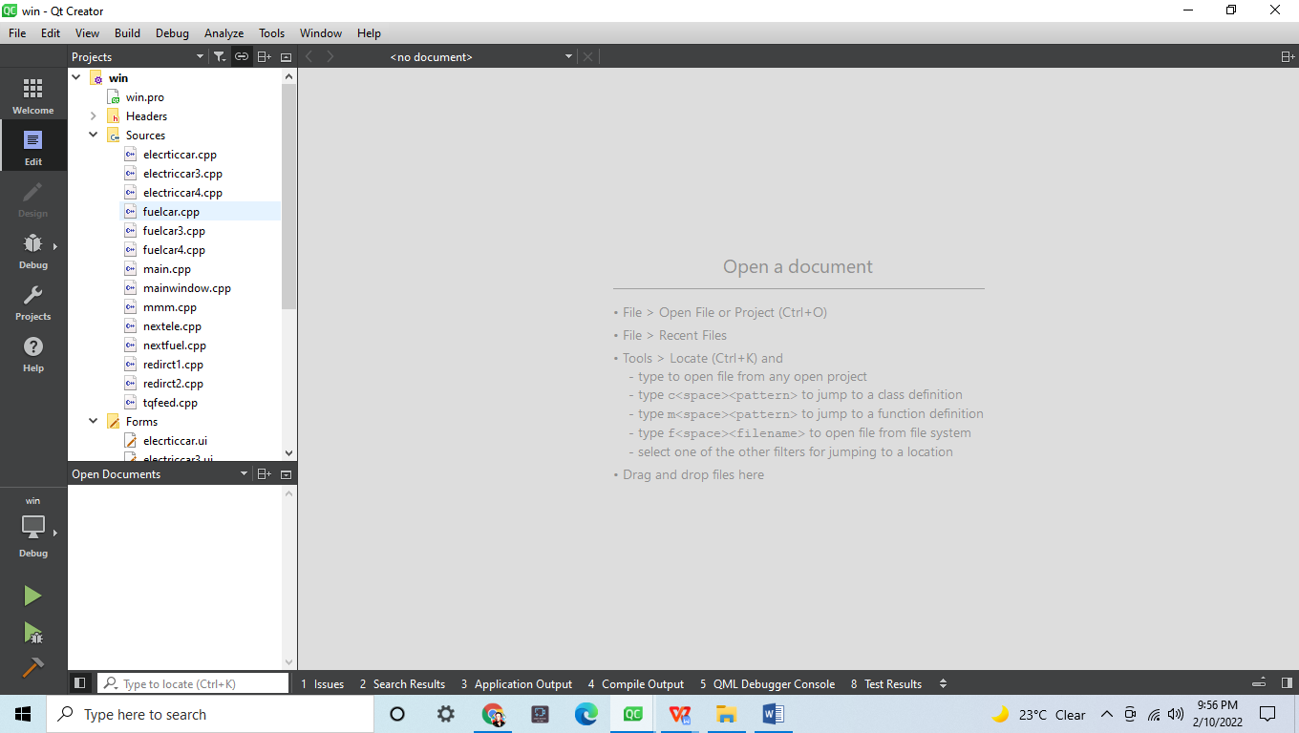

1. **LOGIN PAGE OF OUR WEBSITE**

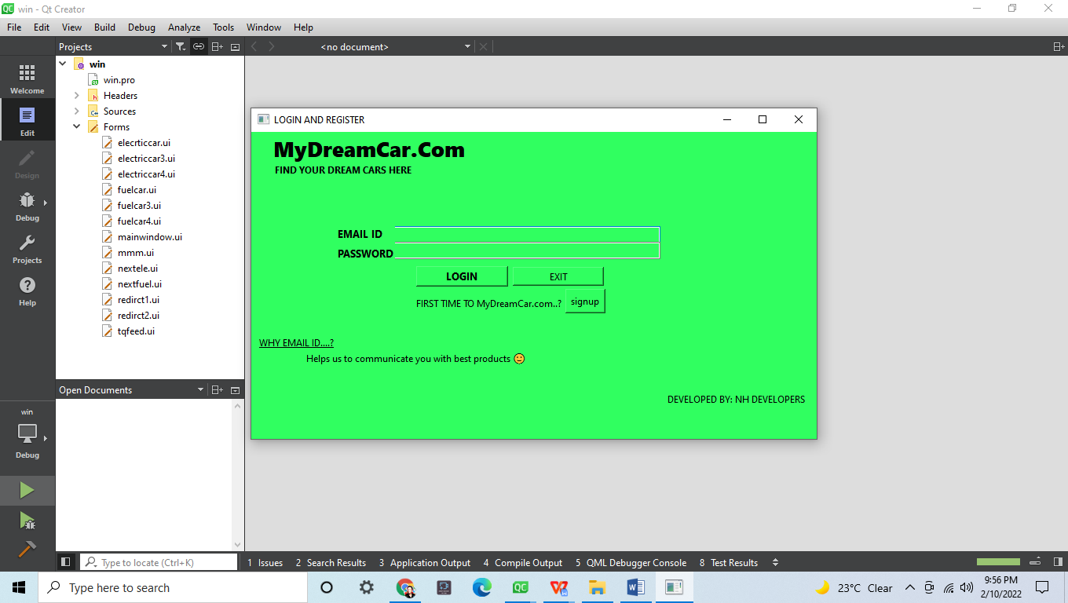

**3 .DATA SECURITY FROM OUR SIDE**

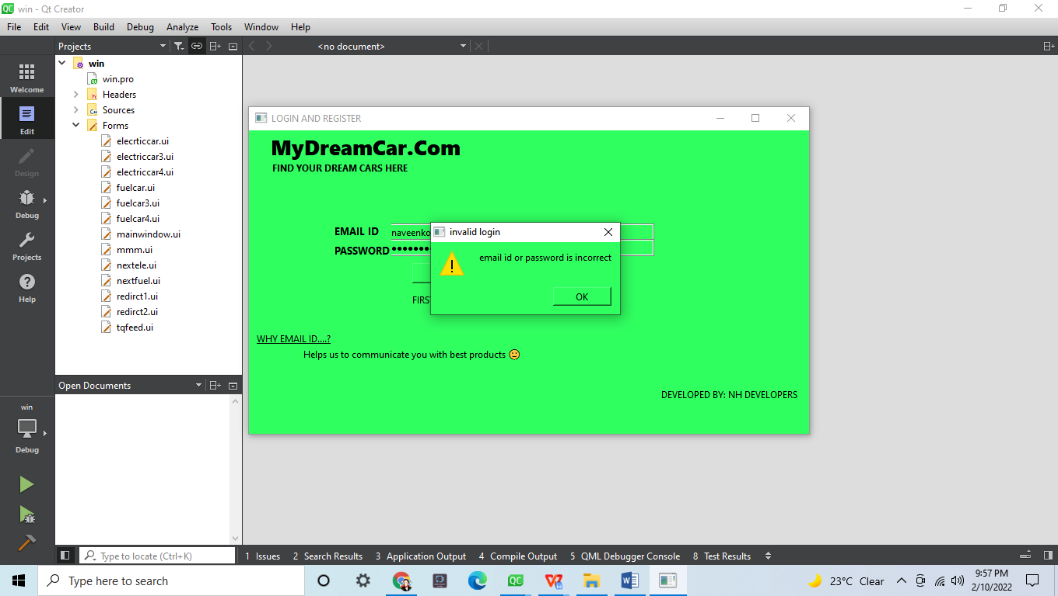

**4.HOME PAGE OF WEBSITE WITH TRANSPARENCY OF PROCESS**

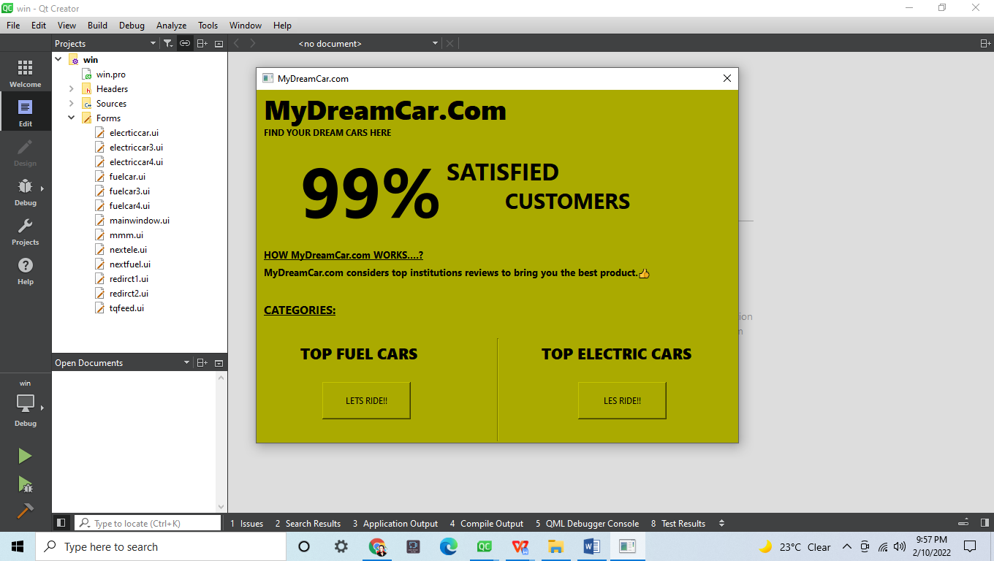

**5.TOP FUEL CARS ON TREND WITH FEATURES**

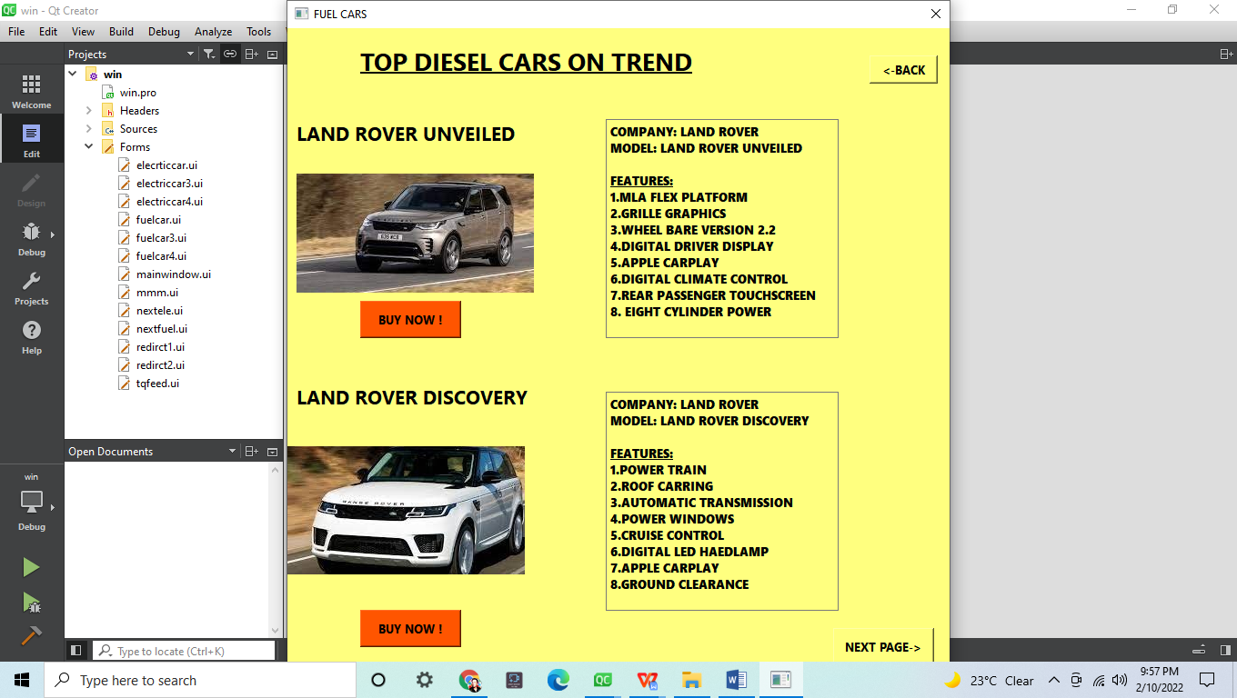

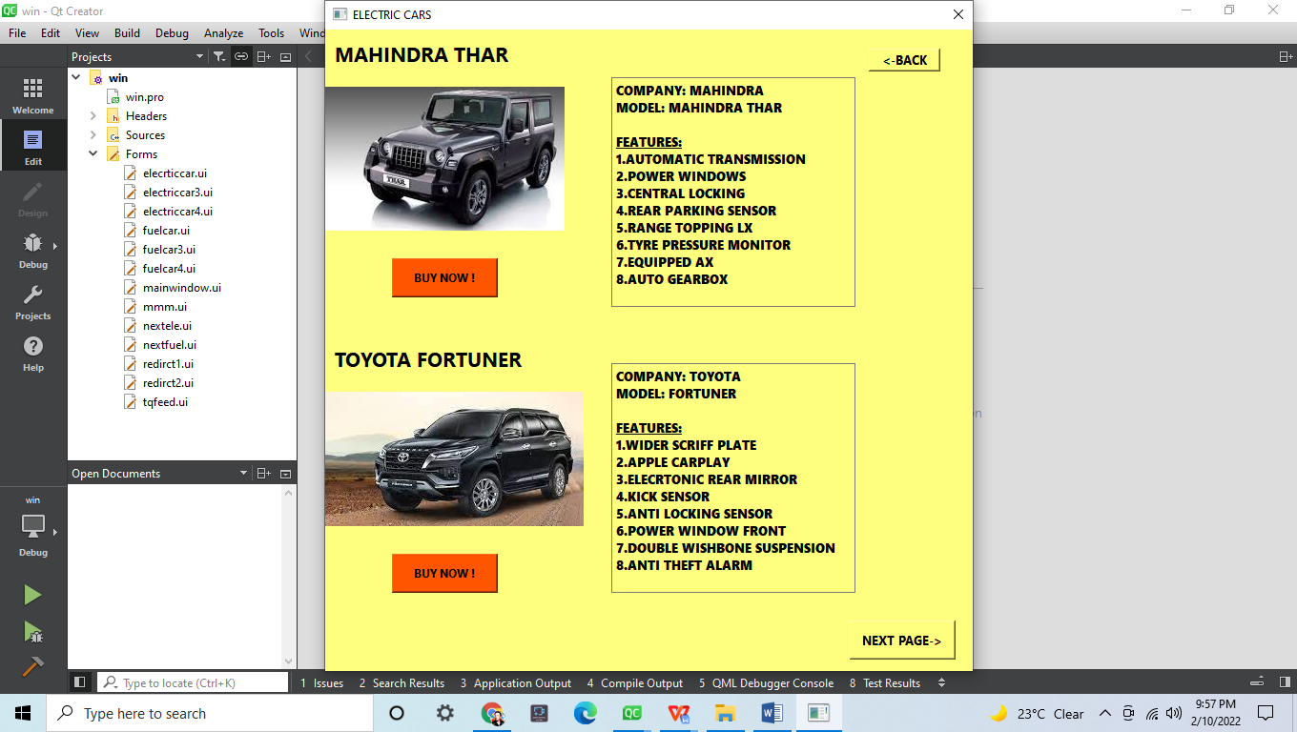

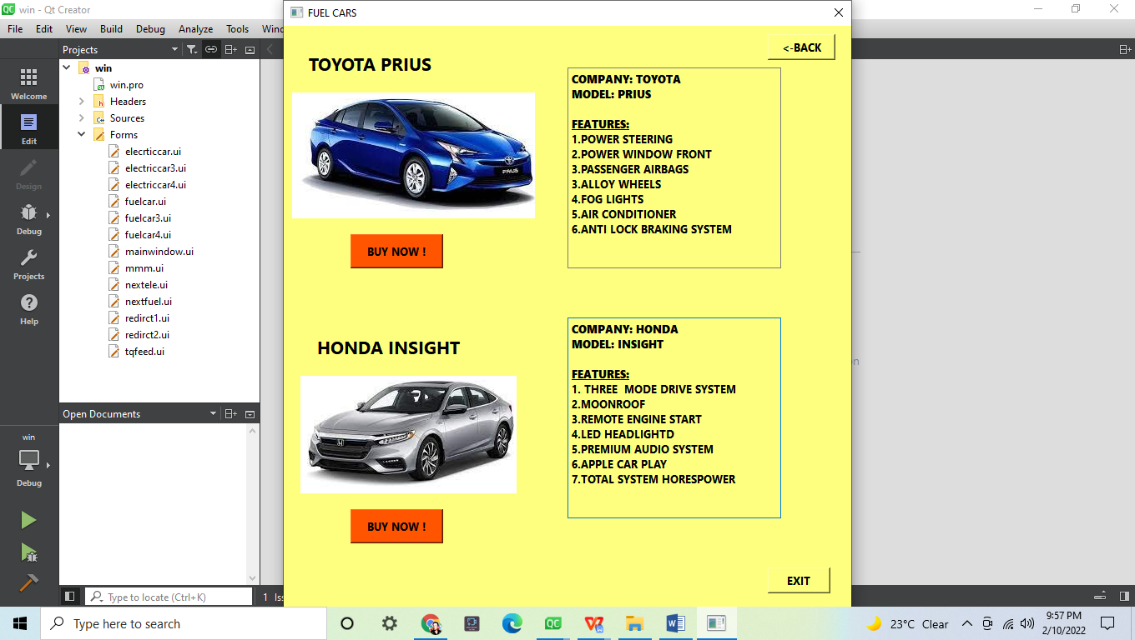

**6.TOP ELECTRIC CARS ON TREND WITH FEATURES**

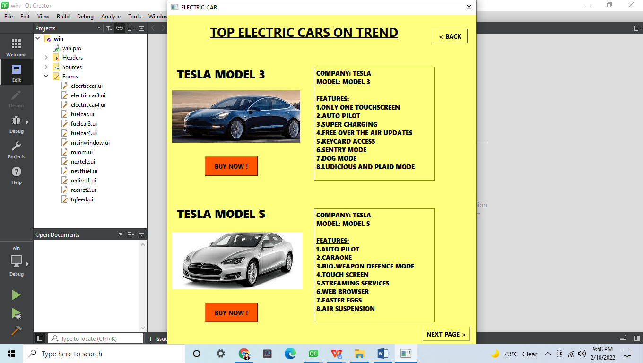

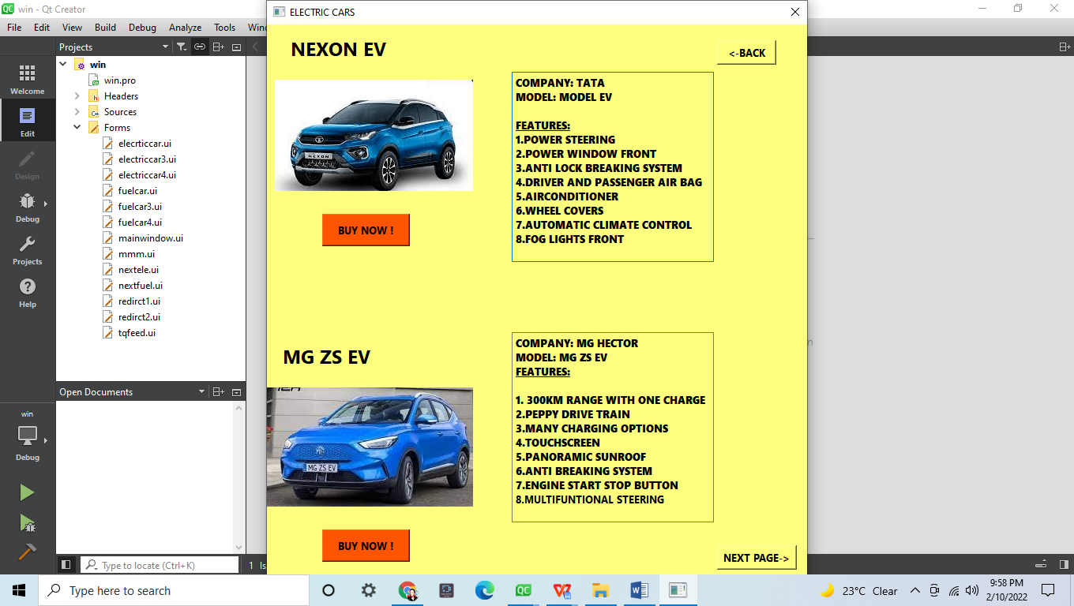

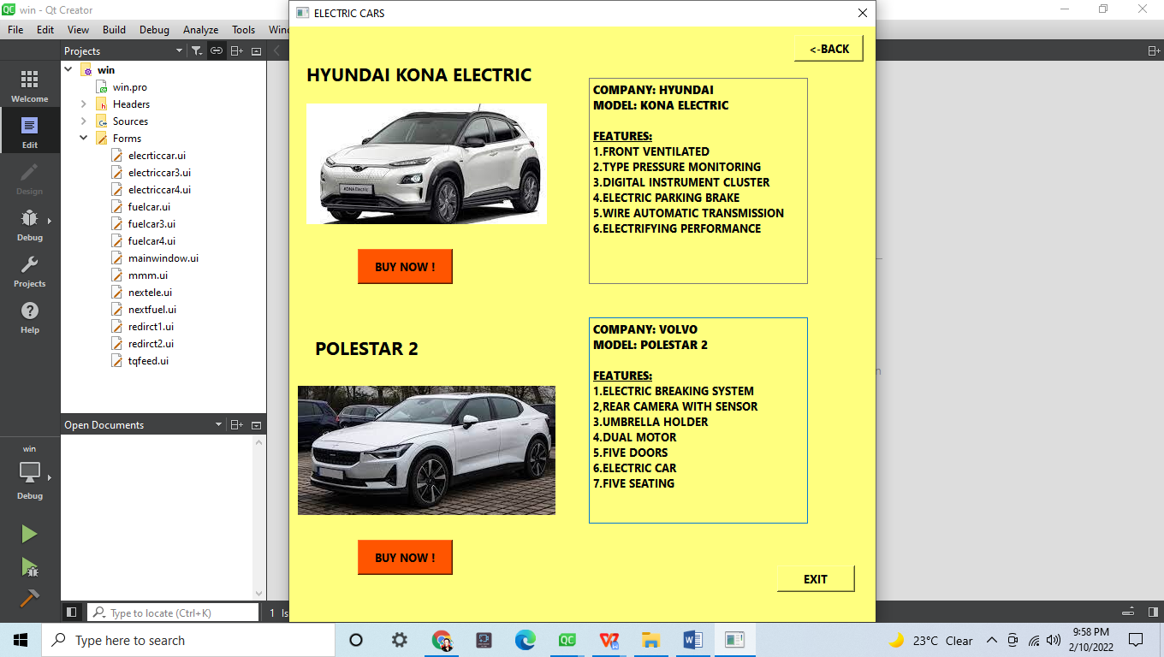

**7.BUY ANY CAR IN “ONE CLICK”**

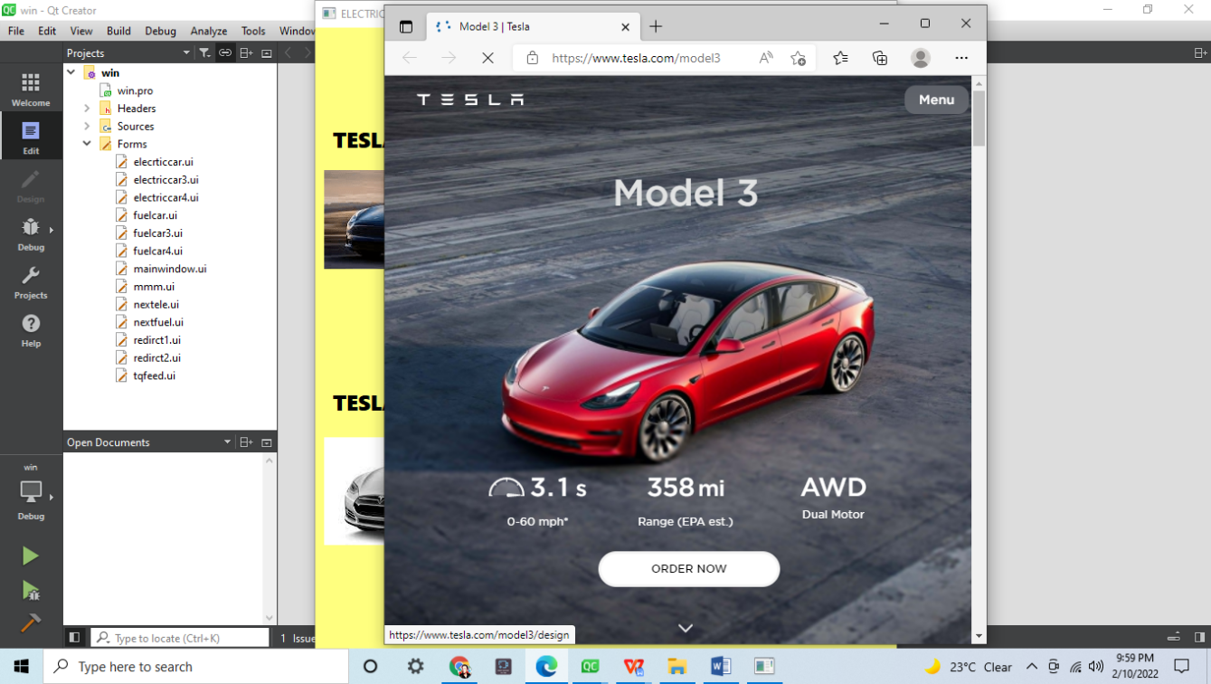

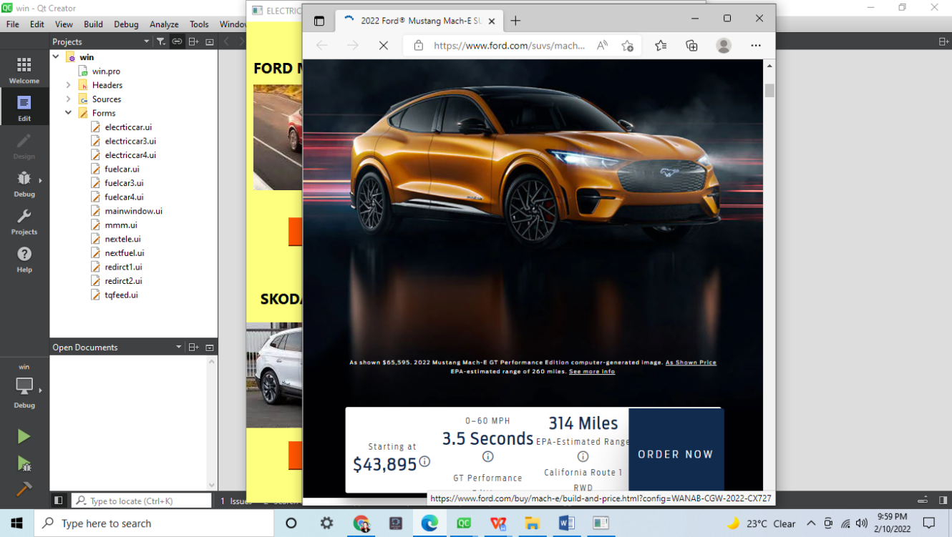

**8.FEEDBACK PAGE WITH INTERACTION OF OBJECT**

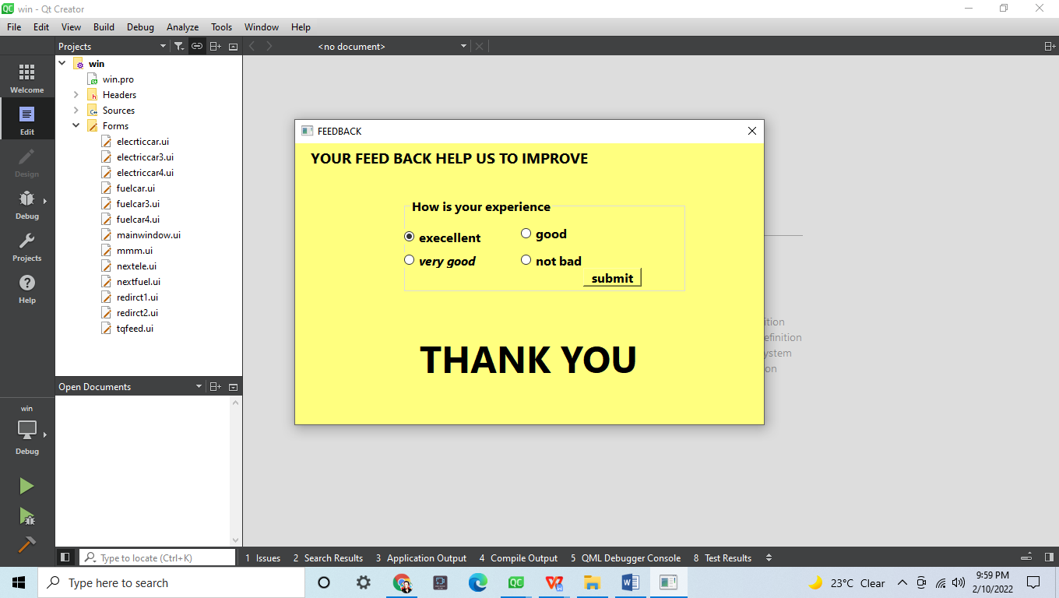

**CHAPTER 5:**

**CONCLUSION:**

LEARNING ANY CONCEPT IS COMMON. THE IMPLIMENTATION OF CONCEPT WITH A

GREAT IDEA DOES MATTER A LOT. WE TRIED TO IMPLEMENT THE CONCEPTS WE

LEARNED IN OBJECT ORIENTED PROGRAMMING USING C++. WHERE WE LEARNED AND

EXPERIENCED A LOT OF THINGS WHICH WE DIDN’T EXPERIENCED IN THOERY.